Predators regulate the taxonomic structure of mixed *Mytilus edulis* and *M.trossulus* settlements in the shallow waters of the White Sea

Vadim Khaitov, Anna Makarycheva, Renata Nematova, Alena Evdokimova

Abstract.

++++++

## Introduction

Mussels of several cryptic species, known as “*Mytilus edulis*” complex (Riginos and Cunningham 2005), are widely distributed around North hemisphere. Species of this complex frequently coexist sympatricaly as do, for instance, *M. edulis* (Me) and *M. trossulus* (Mt) along both coasts of the North Atlantic Väinölä and Strelkov (2011) . The proportion of both species in mixed populations vary in broad limits (Katolikova et al. +++; Väinölä and Strelkov, 2011 but factors regulating species composition in locality is poorly understood.

The most considered factors influencing Mt-Me composition in mixed populations are abiotic ones: temperature and its correlates (Popovic & Riginos, 2019; Wenne et al., 2020), salinity (Riginos & Cunningham, 2005; Ridgway & Naewdal, 2004; Kijewski et al., 2019), surf effects (Tam, Scrosati, 2014; Comesaña et al., 1999). Only few attempts were made to assess the role of biotic interactions in regulation of Mt-Me proportion in local populations. It was shown that proportion of Mt is significantly higher in mussel’s settlements on fucoid’s tally in comparison with surface of ambient ground where Me predominate (Katolikova et al. 2016). In this case, however, the main factor is probably not fucoids as biotic substrate but the force of the surf again. The fucoid’s thallae work as shock absorbers, saving Mt possessing thinner shells (Katolikova et al. 2016). Some attempts have also been made to consider anthropogenic influence as an important factor regulating the distribution of the two species (Väinölä and Strelkov, 2011): the authors believe that Mt was introduced into the White Sea by ship trafic and therefore concentrated in areas next to sea ports.

In fact the only true biotic interaction playing the role in regulating of Mt-Me proportion that was systematically investigated was starfish pressure. As it was shown, starfish let to prey on the Baltic mussels (Mt) and on the North Sea ones (Me) preferably attacked Mt (Kautsky et al., 1990 !!!). In experiments with Mt and Me from Canadian hybride zone sea stars attacked more actively on Mt than on Me defence reactions of which were generally stronger (Lowen et al., 2013).

In practice, the analysis of ecological interactions require numerous samples with high specimens amount. Identification of mussel species by using of expensive and exhausting genotyping do not facilitate it. The use of semi-diagnostic morphological markers, which give the ability to identify species with a high (but not 100%) probability, can facilitate the solution of ecological tasks (Khaitov et al. 2021). The pattern of nacre deposit on mussel shells was suggested as a possible semi-diagnostic marker for probabilistic species identification (Khaitov et al. 2021). Accordingly to this trait, two discrete morphotypes (T and E) were recognized in different seas of the world. These morphtypes are corresponded well to Mt and Me, respectively (Khaitov et al. 2021).

The ecological analysis of the Mt-Me hybride zone in the White Sea has been significantly enhanced by the use of the semi-diagnostic marker mentioned (Katolikova et al., 2016). In particular, the use of morphotypes allowed a much larger number of mussels to be involved in experiments for assessment mussel-stearfish interaction and to obtain more pronounced results (Khaitov et al. 2018). Choice experiments conducted in the White Sea confirmed results from other areas - starfish feel the difference between Mt and Me and prefer to consume the former (Khaitov et al. 2018).

These findings, however, being revealed in cage experiments, do not indicate the role of starfish in regulation of Mt-Me composition in natural conditions. Up to date we do not know if sea stars can change proportions of species in mixed populations in situ. In present investigation we conducted a series of field experiments and observations to answer three questions. (1) Will sea stars attack Mt with higher probability (as was shown in cage experiments) but in conditions close to natural? (2) Would the mussel settlements dominated by Mt more preferable foraging place than those dominated by Me, as it could be expected from the fact that Mt is more preferable prey? (3) Does the Mt-Me proportion change in natural populations after attack of starfish?

## Materials and methods

## Mussel identification

This investigation was based on the indirect species identification by using morphotypes as semi-diagnostic markers. We used approach proposed in Khaitov et al. (2021) which, in short, can be described as follows. We assigned mussels to T-morphotype if nacre was undeveloped in the zone approached to ligament nympha. A thin stripe of prismatic layer uncovered by nacre could be seen in this shell region. In contrast mussels were assigned to E-morfotype if nacreous layer came closely to ligament nympha, no uncovered prismatic layer was recognized in this region. The trait considered could be seen well both on alive mussels after their dissection and on dead shells (including killed by sea stars) collected in the field.

The proportion of Mt in a population (Ptros) is highly correlated with proportion of T-morphotype (PT) in the White Sea (Khaitov et al., 2021) and can be recalculated using the equation as follows:

$$Ptros=\frac{e^{−2.4+5.4PropT}}{1+e^{−2.4+5.4PropT}} \left(Eq1\right)$$

Here $Ptros$- probability to find Mt in a population with known value of proportion of T-morphotype ($PropT$).

However for probabilistic species identification of individual mussels, which is necessary for experiments, the information on proportion of Mt-Me in the site of mussel collection is needed (Khaitov et al, 2021). For mussels of T-morphotype sampled from population with known Ptros the probaility to be Mt could be assessed by the Eq2. For mussels of E-morphotype originated from population with known Ptros the probability to be Me can be assessed by Eq3.

$$P\left(Mt|T\right)=\frac{e^{0.2+3.2Ptros}}{1+e^{0.2+3.2Ptros}} \left(Eq2\right)$$

$$P\left(Me|E\right)=\frac{e^{3.7−4.9Ptros}}{1+e^{3.7−4.9Ptros}} \left(Eq3\right)$$

Here $P\left(Mt|T\right)$- the probability to be Mt if randomly taken mussel possess T-morphotype, $P\left(Me|E\right)$- probability to be Me if a mussel possess E-morphotype, $Ptros$- probability to find Mt in a settlement where the mussel were sampled from. To assess $Ptros$ we used either data on genotyped populations presented in the Kandalaksha bay of the White sea published in Katolikova et al. (2016) or using data on PropT assessed in populations where mussels sampled from folowed by using Eq1.

### Samples of mussel for experiments

To increase the probability of species identification of mussels used in field experiments we sampled material from two populations contrasting by their Ptros. The first population (Pop1) was located on mussel bed in the Voronya Bay (66.92795 N, 32.49098 E, Fig. ++). According to genetic survey (Katolikova et al 2016), the average Ptros in this area equal to 0.11 (see S1 table in Katolikova et al.2016, populations # 24-27). It is close to assessment of $Ptros$ = 0.10 obtained from Eq1, using the proportion of T-morphotype in this population as $PropT$ = 0.03 (the proportion of T-morphotype in samples from Pop1 and used in experiments). Accordingly to these assessments, the probability to be Me for any specimens of E-morphotype sampled from Pop1 can be assessed as $P\left(Me|E\right)$ = 0.96, but specimens of T-morphtype sampled in Pop1 could be identified as Mt with lower probability $P\left(Mt|T\right)$ = 0.63. Thus any randomly taken mussels with E-morphotype sampled in Pop1 can be considered as Me with high probability but degree of taxonomic uncertainty for mussels with T-morphotype sampled in Pop1 is high enough.

The second population (Pop2) was located on mussel bed situated between Telachiy and Oleny islands (67.10613 N, 32.49098 E, Fig. ++). No direct assessment of Ptros was made in this area however knowing the proportion of mussel with T-morphotype in this locality ( $PropT$ = 0.69) we can calculate the proportion of Mt in Pop2 using Eq1: $Ptros$ = 0.79. This value is close to average Ptros calculated for genotyped samples, located closely (populations #18-23, see S1 table in Katolikova et al 2016): $Ptros$ = 0.78. Using this data for mussels sampled from Pop2 we can assess $P\left(Me|E\right)$ = 0.46 and $P\left(Mt|T\right)$ = 0.94 . Thus any randomly taken mussel with T-morphotype sampled in Pop2 can be considered as Mt with very high probability. However degree of taxonomic uncertainty for mussels with E-morphotype sampled in Pop2 is very high (such mussels could be with equal probability assigned both to Mt and to Me).

Mussels from Pop1 and Pop2 were sampled +++ 2017 (experiment 1 and 2) and +++ 2018 (experiment 3). Mussels were washed and cleaned from overgrowing organisms. Only individuals with shell length ranged in ++ - ++ mm were used for further manipulations. Samples from both populations were placed separately in mesh bags and kept in sea water by being suspended from the pier. After several days of adaptations each mussel was labeled by color tag marking their origin (Pop1 or Pop2).

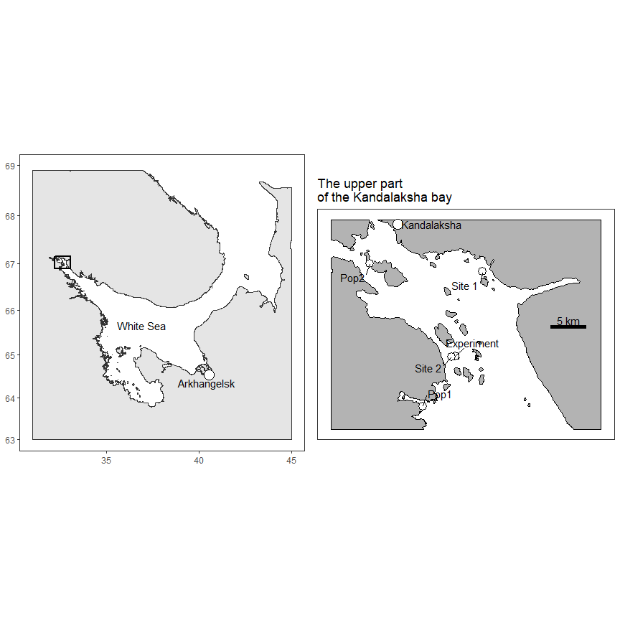 Figure +. The position of points of samples for experiments (Pop1 and Pop2), the point of experimental set up and position of localities (Site 1 and Site 2) where samples for assessment of *A.rubens* influence on taxonomic structure of mussel settlement were taken from.

### Experimental set up

We constructed 30 experimental units consisted of ceramic plate (25 x 25 cm) surrounded by a plastic barrier (3 cm hight) around the perimeter. This barrier prevented the mussel movement outside the experimental unit but allowed sea stars to crawl inside. On the corner of the experimental plate we fastened four ropes which were knot together (appr 30 cm above a center of plate). We tied a cord (50 cm length) with foam float to the point of connection of four ropes mentioned. The foam floats allowed to find experimental units on the bottom and pick them up from board of the boat.

The experimental units were divided into three groups: “Me-dominated”, “Mt-dominated” and “Mixed”. In two experiments conducted in 2017 on each plate from the first group we placed 100 mussels sampled in Pop1. On the plates of the second group we placed 100 mussels collected in Pop2. Finally on the plates of the third group we placed 50 mussels from Pop1 and 50 mussels from Pop2. We used 13 experimental units in the first experiment and 26 units in the second one. In 2018 when we conducted third experiment the design of experimental set up was the same but we placed only 60 mussels on each plate (30+30 in the case of “Mixed” units). We used all 30 experimental plates in this year.

When mussels were set up on experimental units (for all of three eaxperiments) the later were placed on the bottom of an intertidal pool which never visited by sea stars. After two tidal cycles all mussels fast themself on the surface of ceramic plates or on the walls around it but inside the unit, only few marked specimens were washed out. After the processing described all experimental units were submerged on the bottom for the depth about 3 m in the starfish infested area(Fig. ++ point denoted as “Experiment”). Spatial distribution of units from different groups was random and the distance to the nearest neighbour unit was approximately 1 m.

Experimental units were exposed for 61 (experiment 1 in 2017), 121 (experiment 2 in 2017) and 113 hours (experiment 3 in 2018). After exposition period all units were picked up and transposed to the laboratory. Starfish found on each plate were counted and weighted. Dead mussels with color tags (all of them were lack soft tissues which indicated they were eaten by sea stars) were dried. Alive tagged mussels were boiled their soft tissues were removed and shells were dried. Only few not marked mussels were found inside experimental units but some color narked specimens (++% from initially set) were lost.

Dry shells (eaten and uneaten) were measured (maximum distance from the umbo to the opposite side of the shell) using an electronic caliper with an accuracy of 1 mm. The morphotype of each shell was assessed according to Khaitov et al. (2021). This data will further denoted as *“Experimental”* data set.

### Field samples for assessment of sea stars influence on Mt-Me composition

In August 2019 mass swarm of sea stars attacked shallow water mussel populations in the upper part of the Kandalaksha bay (our personal observation). Such massive invasions periodically occur in the area (our personal observation). We used this event to sample mussels in three types of patches. The patches of the first type were intact mussel settlement presented in the starfish crowding area but not attacked still. The patches of the second type were represented by dense clusters of starfish feeding on the mussel patch. And the third type included patches of dead shells visually presented on the bottom surface. Patches of all three types were situated close to each other (the maximal distance between them was several meters).

We sampled patches of each type in two sites (Fig. +, points marked as Site 1 and Site 2). In both sites snorkel diver recognized the suitable place orienting on sea star abundance. When appropriate place was found 10 quantitative samples on each type of patches were taken by using a round core (++ mm diameter). Thus 30 samplings were made in each of two sites.

After the samples were washed through sew-screen (mesh size 2 mm) they were sorted. When sorting the samples we took into account alive mussels and their dead shells (we sampled shell with length exceeded 10 mm) and sea stars. Sea stars were counted and weighted. Dead shells were counted (each valve was counted separately). Alive mussels were boiled, their soft tissues removed and shells dried. On dried mussel shells we evaluated mussel’s morphotype.

Each sample was characterized by values as follow. The proportion of dead shells was estimated as the ratio of the doubled number of dead shells to the sum of this value and the number of live shellfish in the sample. The proportion of T-morphotype (PropT) - as the ratio of number of mussel with T-morphotype to total number of alive mussels in the sample. Finally total starfish biomass was assessed. This data will be denoted further as *“Observation”* data set.

### Statistic processing

All statistical processing and data visualizations were conducted with functions of statistical programming language R 4.05 (R core team, 2021 !!!).

Data from “experimental” data set was analyzed by the means of logistic generalized linear mixed model construction based on binomial distribution with logit link-function (Model 1). The probability to be eaten was considered as a dependent variable in the Model 1. Each individual mussel was codded as “1” if it was eaten by sea star and “0” otherwise. The total amount of analyzed mussels was 5509.

The predictor set for the fixed part of the model included six covaries. No interaction between predictors described bellow was included in the Model 1.

1. Mussel species. In the case of Pop1 and Pop2 we have deal with not mono-species populations. That’s why using morphotypes as a basis for species identification we can identify mussel species only with certain probability (Khaitov et al., 2021). Accordingly to this we constructed a continuous predictor: the probability to be identify an individual as M. trossulus (P_Mt). The values of this predictor was calculated as follow. We evaluated P_MT in Pop1 as P_Mt = 1 - P(ME|E) = 1 - 0.96 = 0.04 for mussels of E- morphotype and P_Mt = P(Mt|T) = 0.63 for mussels of T-morphotype. For mussels collected in Pop2 corresponding values were assessed as P_Mt = P(Mt|T) = 0.94 for mussels of T-morphotype and P_Mt = 1 - P(Me|E) = 0.54 for E-morphotype. The interpretation of this values is obvious: more P_Mt - more probability that the concrete mussel is Mt.

(2)Number of “conspecifics” (N_consp). For each mussels included in the analysis we calculated the number of mussels of the same morphotype presented in the experimental unit where this mussel was placed. We interpret this predictor as follow: when this value low the mussel of given morphotype is surrounded mostly by mussels likely belong to another species, otherwise when N_consp is high a mussel is predominantly surrounded by conspecifics. This value will be in average high for mussels placed into “Mt-dominated” or “Me-dominated” units and low for mussels placed in “Mixed” units.

(3)Proportion of mussels of T-morphotype (P_T). This value describes the taxonomic structure of a mixed population. The lowest value of this predictor is in the “E-dominated” units, the higher one - in “Mixed” and the highest values presented by “T-dominated” units.

(4)Mussel size (L) , (5) sea stars biomass (B_aster) and (6) total amount of mussel (N_tot) are self-evident predictors. They was used as a technical covariates which is needed since mussels of different size were used, the amount of sea stars crawled in varied between experimental units and different number of mussels was placed on experimental units in 2017 and 2018.

All predictors were scaled by subtracting the mean and dividing by the standard deviation. The scaling of the predictors allowed us to compare the power of different predictors by the means of comparing the regression coefficients.

The random part of the mixed model described the variation of model intercept. Two random factors was included in the model: The factor “Experimental unit” was hierarchically nested within the “Experiment” factor .

The Model 1 was fitted by using glmer() function from lme4 package (Bates et al 2015). The validity of model fitted was checked by means of residual plots. No violations of logistic regression analysis was found.

The second, “observation” data set was analyzed by the means of generalized additive model construction (beta distribution with logit link-function, Model 2 thereafter). The proportion of mussel of T-morphotype among alive mussel (PT_alive) was considered as dependent variable. As a main predictor in the model we considered the discrete factor “Patch Type” with three levels described above. The biomass of sea stars was included in the model as an additional covariate. The Model 2 was fitted by gam() function from the mgcv package (Wood, 2017 !!!). The factor “Site” was included in the Model 2 as a random effect smoother (Pedersen at al, 2019). The Model 2 construction was followed by pairwise comparisons of model predictions for three levels of “Patch type” predictor. For the comparison Tukey test was applied by using glht() function from the “multcomp” package (Hothorn et al 2008 !!!).

## Results

### “Experimental” data set

Since all predictors in the model constructed (Table ++) were continuous and scaled we can directly compare the power of their influence on dependent variable. The most powerful predictor (Table ++) was sea star biomass. The high positive coefficient denotes increase probability to be eaten when starfish biomass increased (Fig. ++).

The second most influential predictor was probability to be Mt (P_Mt). The positive value of corresponding regression coefficient (Table +, Fig. ++) can be interpreted as higher probability to be eaten for mussels of T-morphotype (maximal value of P_Mt) in comparison with mussels of E-morphotype (minimal value of P_Mt).

The third most powerful predictor (N_total) was associated with negative regression coefficient. It means that probability to be eaten was lesser in more abundant mussel settlement (Table +, Fig. ++).

The next predictor, mussel size (L), again negatively correlated with probability to be eaten (Table +, Fig. ++). Thus starfish consumed more actively smaller mussels than larger one.

The last predictor describing abundance of mussels of the same morphotype for a given mussel (N_consp) was negatively correlated with dependent variable (Table +, Fig. ++). Thus if on experimental plate there were negligible number of specimens taxonomicaly similar to given mussels the probability to be eaten for this mussel was higher than for a mussel surrounded by higher conspecific’s amount.

No significant associations between probability to be eaten and proportion of T-morphotype (P_T) was revealed (Table +., Fig. +).

Table +.Parameters of the model describing the probability of being eaten as a function of predictors. Shown are parameters from the fixed part of the Model 1.

| Term | Estimate | SE | z-statistic | p.value |
| --- | --- | --- | --- | --- |
| $(Intercept)$ | -1.208 | 0.0924 | -13.08 | 0.0000 |
| $P_{Mt}$ | 0.370 | 0.0547 | 6.76 | 0.0000 |
| $N_{consp}$ | -0.138 | 0.0631 | -2.19 | 0.0289 |
| $PropT$ | -0.105 | 0.0799 | -1.32 | 0.1870 |
| $N_{total}$ | -0.319 | 0.0852 | -3.75 | 0.0002 |
| $L$ | -0.182 | 0.0373 | -4.88 | 0.0000 |
| $B_{aster}$ | 0.673 | 0.0942 | 7.15 | 0.0000 |

Model terms: $P_{Mt}$- probability to be identified as Mt; $N_{consp}$- number of conspecifics for given mussel in the experimental unit; $PropT$- Prportion of mussels of T-morphotype; $N_{total}$- number of mussels in the experimental init in the end of exposition; $L$- mussel size; $B_{aster}$- sea stars biomass in the end of the exposition

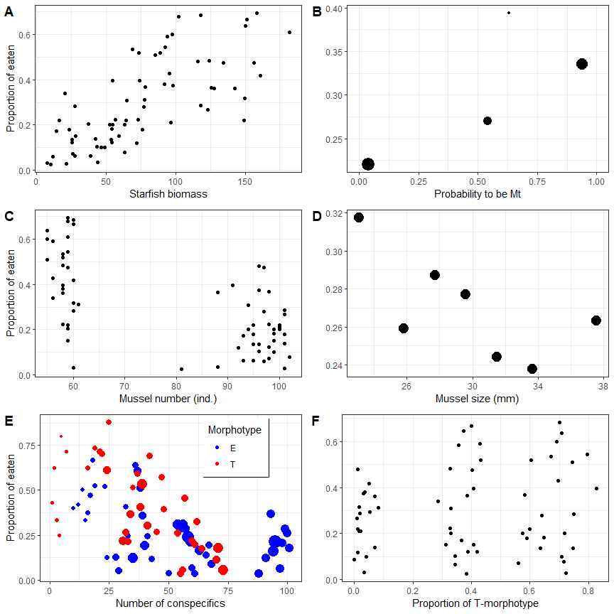

Figure +. Proportion of mussels eaten at different values of the predictors included in the regression Model 1. The figure shows the raw data summarized for three experiments. **A.** Relationship to starfish biomass. Each point reflects different experimental unit. **B.** Proportion of eaten mussels among specimens with different probability of being defined by morphotype as Mt. Each point represents the proportion of eaten among individuals having the same P_Mt value. The size of the dots is proportional to the number of mussels in each particular group. **C.** Proportion of eaten individuals among mussels presented on experimental units with different numbers of live mussels found at the end of the experiment. Each point corresponds to a different experimental unit. **D.** Proportion of eaten individuals among mussels of different size. Each point corresponds to particular size class. **E.** Proportion of eaten individuals among mussels with different numbers of conspecifics within the experimental unit. The size of the point is proportional to the number of mussels in each particular group. **F.** Relationship to prportion of T-morphotype. Each point reflects experimental unit.

### “Observation” data set

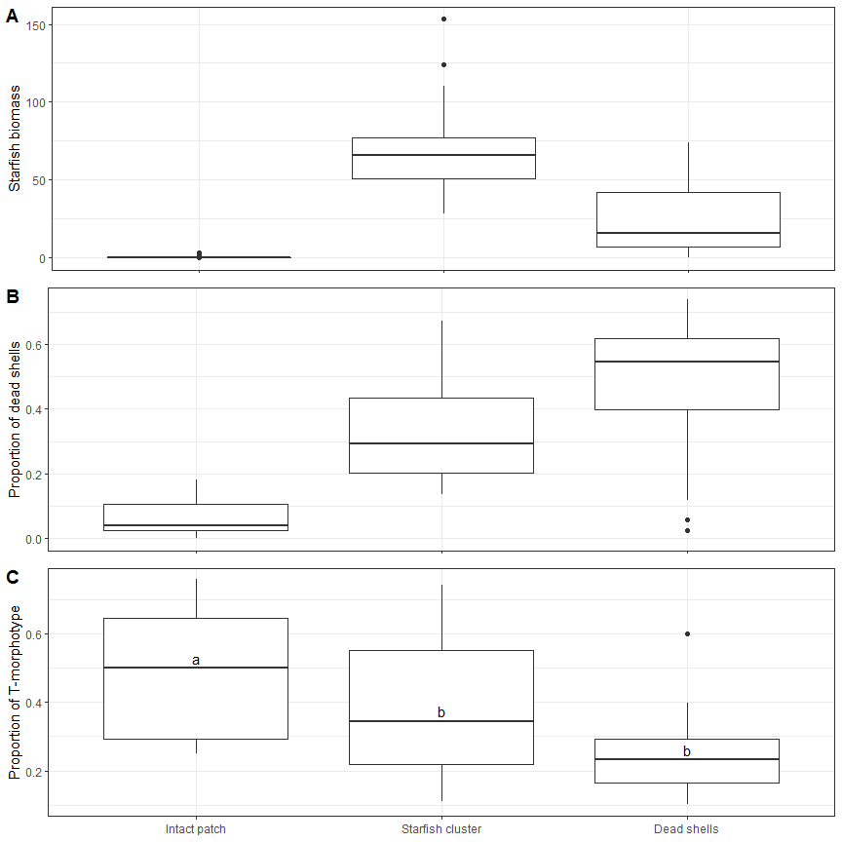

Figure +. Boxplot representing the *A.rubens* biomass (**A**), proportion of dead shells (**B**) and proportion of mussel of T-morphotype (**C**) in samples from three types of patches. On the panel C the results of post-hoc comparisons for regression Model 2 are presented: different letters denote significant difference.

The biomass of sea stars was differ on pathches of differing types showing minimal value on the intact mussels and maximal one on crowding starfish (Fig + ). The proportion of dead shells was minimal on alive mussel patches and maximal on dead shell’s patches (Fig +). The proportion of T-morphotype gradually decreased from intact patches through patches of starfish clusters to patches of dead shells (Fig +). The regression model constructed (Table +) revealed significant dependence of $PT_{alive}$ on all predictors (Table +). Pairwise post-hoc comparison revealed significantly higher proportion of $PT_{alive}$ in intact mussel patch than in patches surrounded by sea stars and in patches of dead shell (Fig. ++). The difference between last two groups was not significant (Fig +). Some weak positive correlation between $PT_{alive}$ and sea stars biomass was found (Table +).

Table +.Parameters of the model describing the proportion of T-morphotype among alive mussels as a function of predictors. Shown are parameters from the fixed part of the Model 2.

| Term | Estimate | SE | z-statistic | p.value |
| --- | --- | --- | --- | --- |
| $(Intercept)$ | -0.048 | 0.453 | -0.106 | 0.9158 |
| $Patch_{Starfish clusters}$ | -0.970 | 0.308 | -3.145 | 0.0017 |
| $Patch_{Dead shells}$ | -1.279 | 0.210 | -6.085 | 0.0000 |
| $B_{aster}$ | 0.008 | 0.004 | 2.236 | 0.0254 |

‘Intact patches’ were used as a base level for the factor ‘Patch’

## Discussion

In this study we provide the first evidence that *Asterias rubens* can discriminate between sympatric *Mytilus* species in natural conditions. All previous attempts to determine whether *M. edulis* or *M. trossulus* is more susceptible to predation by *A. rubens* were performed in closed aquarium set up in laboratory or in natural habitats (Loven et al., 2013; Khaitov et al., 2018; Kautsky et al., 1990). Such closed microcosms may provide conditions shifted in comparison with natural one. In our experiments we offered sea stars infesting the natural habitats a free choice between artificially constructed settlements of mussels differing in their taxonomic composition. This approach was made possible by using a low-cost method of identifying mussel morphotypes followed by estimating the probability of belonging to one of the two cryptic mussel species, as was proposed in Khaitov et al. (2021). Due to this approach, we were able to form several dozen experimental units, on which several thousand mussels were landed.

The second advantage of our approach was that we included several covariates potentially affecting the probability of mussel mortality (due to be eaten) in a single analysis. The influence of some of these covariates was self-evident. For example, we have shown that the greatest influence on the probability of being eaten is associated with abundance (biomass) of sea stars attacking experimental units (Table +). It seems to be a trivial and expected correlation: more predators, more chance that the prey will die.

The another trivial dependency revealed in our analysis was that the probability to be eaten was associated with prey size. However the fact that predators preferred smaller mussels (Table +) seems to be intriguing. We have found the same pattern in our aquarium experiments (Khaitov et al., 2018) as well it was observed by other authors (O’Neill et al., 1983 !!!; Hummel et al., 2011;) although opposite pattern was observed as well (Dolmer, 1998 !!!; Aguera et al 2020 !!!).The choice of smaller (but obviously not the smallest) mussels may be related to that the delicate walls of the predator’s stomach, embedding between the valves of the victim, suffer less mechanical damage if the smaller individuals are attacked (Hummel et al., 2011). However, this vector of choice probably depends on prey density: in scarce mussel populations sea stars look for larger victims than in dense populations (Aguera et al. 2020). Intraspecific competition between sea stars can also be important in choice of mussels of larger size when competition between predators become stronger (O’Neill et al., 1983). To note, the value of the regression coefficient (Table + ) associated with prey size was one of the lowest in the model (recall that all predictor values were standardized, which allows us to directly compare their influence). Thus the probability of being eaten depends only to a small extent on the size of the prey.

The one more covariate which was initially expected to be associated with probability of being eaten was total amount of mussels presented in the experimental unit (Table ++). The negative coefficient indicates that the more mussels in the experimental unit, the less probability of being eaten. This is the dependence inherent for predators showing functional response of Type II (Holling, 1956 !!!), which is typical for sea stars (Dickey et al 2021). In the case of such functional response, when the prey density increases the proportion of prey consumed per predator per unit time should decrease (Smith & Smith !!!).

What was more interesting was that the one of the highest values among the coefficients in the model was the coefficient associated with the taxonomic status of prey. In this work, we evaluated the belonging of a specimen to one or another species basing on the assessment of mussel morphotype. By its nature, morphotype is a semi-diagnostic trait (Khaitov et al., 2021) that allows identifying the species only with a certain probability, which depends, in turn, on the ratio of Mt and Me in the mixed settlement. Using empirical models constructed on the basis of genotyped specimens (Khaitov et al., 2021), we estimated the taxonomic status of mussels as the probability of being *M.trossulus* (*PMt*). The positive value of the regression coefficient for this predictor (Table ++) indicates that the probability of being eaten increases as *PMt* values increase. Indeed, in total, combining results of all three experiments (Fig. ++) we can see that among Mt-like mussels (*PMt* = 0.94) 34% was eaten whereas 22 % was eaten among Me-like mussels (*PMt* = 0.04). It is noticeable that mussels with intermediate values of *PMt* tending to possess intermediate proportion of eaten (Fig. ++). The latter fact indicates that in mixed populations, the dominant and minor morphotypes retain their species specificity. In other words, sea stars recognize mussels of a rare morphotype as representatives of a species other than the species dominating in this settlement.

Thus, our study confirms that even under conditions as close to natural as possible, sea stars consume Mt with greater preference than Me, as has been shown in aquarium observation (Khaitov et al., 2018). At present there is no unequivocal explanation for this pattern. On the one hand, it is known that Mt have a lower weight of soft tissues, and hence a lower energy value than Me (Penney et al., 2008). That’s why another consumers, the humans, prefer *M.edulis* and *M.galloprovincialis* lacking this disadvantage (Penney et al., 2008; Michalek et al. 2016). On the other hand, sea stars in its prey choice is guided either by tactile or chemical signals from the prey and these signals hardly directly associated with energetic status of different mussels species rather prey size and parameters of prey handling might play a role. It is possible that the reason lies in the different flexibility of the shells of species: Mt have a thinner and more flexible shell than Me (Beaumont et al., 2008). This may reduce the handling time and make the shell opening more safe and less energetically expensive that make Mt more preferable prey.

Chemical signals may also play a role. In experiments conducted by Lowen et al (2008) sea stars, having no tactile contact with Mt and Me seating in different parts of aquarium, tended to move to those part which was occupied by Mt. The nature of the chemical signals is unclear, but there is an obvious candidate for this role: the glycoprotein KEYSTONEin, whose release stimulates sea stars to attack mussels (Zimmer et al., 2016, 2017). This glycoprotein is localized in the epidermis, extrapallial fluid and shell periostracum (Zimmer at al., 2017), i.e. in those body parts which is related to shell formation. Considering the fact of difference in thickness of Mt and Me shells (Beaumont et al., +++) it is highly possible that mussels of two species produce KEYSTONEin in different quantity (or, possible, produce species specific KEYSTONEins).

Initially, our hypothesis was that populations dominated by Mt (i.e., T-morphotype dominated experimental units) would be hit the hardest by starfish attacks. Surprisingly but despite the high vulnerability of Mt that was considered above, we did not observe a higher probability of being eaten for mussels from experimental units that were dominated by Mt. The probability of being eaten was not dependent significantly on taxonomic structure of settlement (Table +). We suppose that a possible resolution of this paradox may be related to the last of the predictors included in our model, the number of conspecifics (*Nconsp*) in experimental units.

The abundance of conspecifics is high for a mussel, let it be the individual of T-morphotype, if it presents in a settlement dominated by individuals of the same morphotype. Similarly, this value will be high for any E-morphotype mussel in a settlement dominated by E-morphotype. The value of this predictor decrease if a mussel of any morphotype presents in mixed settlement. However the smallest value would reach if mussel of given morphotype situates in a settlement dominated by mussels of another morphotype. Thus, a negative coefficient for this predictor means that the minimum probability of being eaten will be observed if a mussel exists among its conspecifics. The highest probability of being killed by a predator will be for alone mussels living among aliens. The pattern observed may testify to some cooperation between conspecifics, as a result of which mortality may decrease.

The cooperation of mussels, as such, manifested by the formation of dense aggregations, is a reliable defense mechanism against predators (Okamura, 1986; Aguera et al., 2020; Reimer & Tedengren, 1997). It is possible that alone alien mussel will be pushed to the periphery of aggregations or outside them, becoming more available prey for sea stars. It is known that Me and Mt are differ in their efforts to form aggregation (Liu et al., 2011) but how it would be translated into their defense against predators is still unknown. Our results allow to suppose that this effect may be related to how the mussels of different species organize themselves when clumping in mixed and mono-specific populations.

If the pattern described really exists, then the “pure”, mono-specific, settlements expected to be more protected against sea stars. This, apparently, explains the absence of a clear dependence of the probability of being eaten on the taxonomic composition of mussel’s settlements: cooperation inside a pure settlement promotes to mussel defense. At the same time, one would expect a higher mortality of mollusks in the mixed settlements. However, we did not observe a clear increase in the probability of being eaten for mussels in settlements with medium *PropT* values (Fig. ++). One of possible reason may be associated with local redistribution and segregation of mussels of different species inside a patch. Obviously additional studies are needed to analyse this phenomena.

The preference by sea stars for one of the mussel cryptic species revealed in this and previous studies (Lowen et al., +++; Khaitov et al. +++) does not yet mean that predators can effectively control the taxonomic composition of settlements when two species exist in common habitat. In short-time experiments such effect is almost impossible to observe: if let sea stars to consume mussels in experimental conditions for long time they eat out practically all preys (personal observation). At the same time, mass invasions of sea stars, which periodically occur in shallow water habitats all over the world (Galtsoff, Loosanoff, 1939 !!!; Dare 1982), and in the White Sea in particular (Naumov 2011 !!!), can be considered as a natural experiment allowing to estimate the role of predators in regulating not only the abundance of prey, but also the taxonomic composition of their settlements.

In 2019, we observed swarms of starfish in shallow water (at 1-3 m depth) at many points in the upper part of the Kandalaksha Bay (personal observation). It is known that during such invasions predators can eat up significant amount of mussel’s population (Galtsoff, Loosanoff, 1939; Dare 1982; Witman et al 2003!!!; Kamermans et al., 2009; Garcia, 2015 !!! and references therein). A starfish swarm moving through mussel settlement leaves behind a “scorched earth”, the mussel free area (Seed 1968 II !!!).

In our case, we did not observe a classic mussel bed looking like a continuous cover consisting of large patches occupied by mussels neighboring with mussel free area, extending for many hundreds of square meters (see Commito et al. 2006 for image), our mussel settlements were represented by individual small clumps (several tens per square meters). Starfish attacking these patches formed clearly distinguishable dense assemblages. Usually near intact and attacked patches, we also found come small fields covered with dead shells.

We cannot state surely that the fields of dead shells are the consequences of sea star attacks and that those patches which we denoted as “intact” are the settlements that have not yet been attacked. However, the proportion of dead shells in the settlements expectedly increases in the series “intact patches- starfish clusters - fields of dead shells” (Fig. ++). The biomass of starfish in this series, again expectedly, shows a maximum on clusters of starfish (Fig. ++). All these facts allows us to consider the mentioned series as a temporal sequence.

The proportion of T-morphotype mussels gradually decreased in the mentioned series (Fig. ++). Although there were no statistically significant differences between samples from starfish clusters and from fields of dead shells both this groups differed significantly from intact patches. Taking into account that the distance between samples was short and all samples were taken from the same habitats, it seems likely that the obtained pattern reflects not the spatial segregation of two mussel species, but rather changes in the taxonomic structure of mussel settlements after sea star attacks. Predators are thus capable to reduce the frequency of Mt in mixed settlements by several times. Accordingly to model fitted (Table ++) after an intact patch was attacked the proportion of T-morphotype mussels increase by e-1.25 = 0.29 times (i.e.decrease by 3.5 times). Thus the results of our study allow to treat predators as one of the important factors regulating the distribution of Mt and Me.

It is also likely that the segregation of species in gradients of environmental factors noted in other works (Riginos and Cunningham, 2005; Stuckas et al., 2017; Katolikova et al., 2016; Innes and Bates, 1999; Dias et al., 2009) is, at least in part, the result of interaction with predators. For example, one might expect that the high proportion of Mt in freshened areas (Riginos and Cunningham, 2005; Stuckas et al., 2017) may be determined not only greater tolerance of this species to reduced salinity, but rather by the fact that sea stars may be rare in these habitats. Indeed, the feeding rate of sea stars decreases with decreasing salinity, at salinity of 12 ppt sea stars do not feed at all (Dickey et al 2021). Taking the fact that in natural conditions sea stars prefer Mt we can assume that in those marine ecosystems where there is a pronounced salinity gradient, freshened areas would be a sort of refugium for Mt.

In the Kandalaksha Bay of the White Sea, where our work was carried out, the upper part of the bay is strongly freshened due to the inflow of the large Niva river. At the top of the bay, the surface salinity usually does not exceed 12 ppt (Katolikova et al., 2016). Sea stars are absent here (personal observation), but mussel settlements dominated by Mt are numerous (Katolikova et al., 2016). When moving away from the bay’s top the salinity increases and *A.rubens* becomes a common species in the upper sublittoral (personal observation), while the proportion of Mt decreases (Katolikova et al., 2016). The observed pattern is quite consistent with the above hypothesis.

However, if our assumption about the role of sea stars, as a keystone predator restricted in its distribution by salinity is correct, then we can expect that this pattern will not appear at the sites of inflow of small rivers. Rivers of lower power seems to be not able to stop starfish attacks, at least in the sublittoral, where the freshwater layer may not penetrate at all. Thus the dependency of Mt frequency on salinity might not be well seen in those regions where desalination is associated with small river discharge. At the same time, global desalination due to climatic changes (or anthropogenic influences) may lead to a significant reduction of sea stars abundance (Dickey et al. 2021) and as a consequence, it will give an opportunity to Mt widely spread over the area.

Additional pattern which was found in our observations is the positive correlation between starfish biomass and the proportion of T-morphotype among alive mussels (Table +). This may indicate that starfish are concentrated more in those areas where Mt frequency was higher. However, this correlation is so weak (although statistically significant) that it is too early to draw unambiguous conclusions regarding this relationship.

## Conclusion

We have answered all three questions stated in our paper. Indeed, sea stars are prefe to attack Mt in natural conditions. However, we cannot say that settlements dominated by Mt are the most attractive foraging sites for sea stars. Apparently, in mixed Mt and Me settlements, there are some undescribed intra- and interspecific interactions that may help to increase the survival rate of mussels in single-species populations. At the same time, it leaves no doubt that predators can effectively influence the taxonomic composition of mixed settlements.

Thus the predators contribute to some purification of the native *M.edulis* settlements of the White Sea from the recently arrived *M.trossulus*. In the future, studies should be expanded to consider the role of other mussel-eating predators (primarily oystercatchers and eiders) in this process.

## Acknowledgments

## Reference

Riginos C, Cunningham CW (2005) Invited review: local adaptation and species segregation in two mussel ( Mytilus edulis Mytilus trossulus) hybrid zones. Molecular ecology 14:381–400

Väinölä R, Strelkov P (2011) Mytilus trossulus in Northern Europe. Marine Biology 158:817–833. <https://doi.org/10.1007/s00227-010-1609-z>